The next page is the attached BOM for our first prototype run, with a few exceptions. The inductor is missing because we need to find out what an optimal saturation current would be for it. I’d need someone to calculate what that would be if possible; the formula is in the datasheet. In the schematic, Q1 is no longer available online so I found what I believed to be a suitable replacement; I’d need someone to double check its suitability. The idea I’d like to try is making one prototyping board using the SMD passive components and use the QFN24 to DIP24 adapter boards to swap out the regulator ICs as needed to reduce costs as much as possible. I plan to order 5 of each IC, which are the BQ24195L and BQ24195. These are the main differences between the two specified by the datasheet:

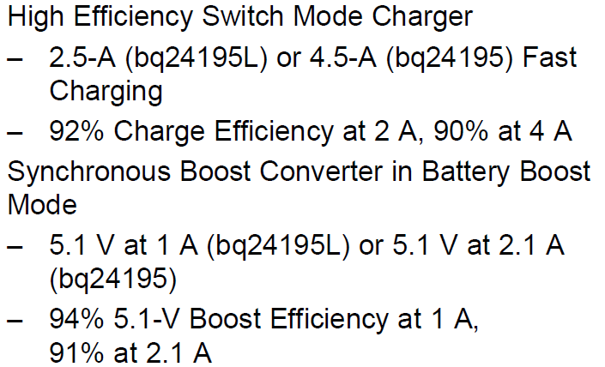

Let me know if this prototyping procedure is suitable or not, or if we should adjust or add to the BOM. All I did to compile it was go through and pick out the components that were as closely related to the datasheet’s specifications as possible. I can add and adjust as needed, and I can also try my hand at designing the PCB using Eagle since I’m not familiar with Altium. The datasheet strongly suggests keeping all the components as closely spaced as possible to reduce noise.

The datasheet also suggests that this chip uses an I2C interface for some of its on-board control systems. I’m not familiar with using this kind of protocol, so I’m wondering if anyone can give me some insight as to how difficult working with these protocols will be for a circuit like this. I’ve never used it, but from what I’ve researched about I2C is it doesn’t look too complicated, I’d just need someone to show me how to use it properly.

The customer reference numbers on the BOM refer to their listed components below.

